RET — Timing Evidence Report
• Team: Rafael Ricardo Torres Choperena
• Boards: ESP32-C6-DevKitC-1 (esp32c6_devkitc/esp32c6/hpcore), native_sim/native/64
• AI use: Week 1: Antigravity (Gemini) — initial RET structure and EARS task set. Week 2: Antigravity (Gemini) — superloop flow table and root-cause analysis of cmd_calib(). Week 3: Antigravity (Gemini) — devicetree overlay port, silicon comparison, and sampling_thread analysis. Week 4: Antigravity (Gemini) — ADR-001 drafting, A/B table, and thread stack high-water mark table. Week 5: Antigravity (Gemini) — CTF tracing analysis, preemption event chain, and tracer overhead evaluation. Week 6: Antigravity (Gemini) — RTA Python script (`rta.py`), ADR-002 & ADR-005 drafting, and schedulability analysis.
Living document — updated every week; handed in at the workshop (week 7) and at the close (week 14).
House rule: "show me the trace" — every timing claim cites a measurement.
1. The system and its task set
Requirements first — one sentence each, EARS style (when/while <condition>, the system shall <response> within <deadline>) — then the task that implements them:
ID | Requirement
REQ-SAMP-01 | While the node is powered on, the system shall sample the pressure sensor, check the e-stop condition, and update the valve PWM phase every 1 ms (1 kHz) with bounded jitter.
REQ-CTRL-01 | While the system is irrigating, the control loop shall compute the PI control law and update the valve duty cycle every 10 ms (deadline = period).
REQ-ESTOP-01 | When an overpressure condition is detected, the system shall close the valve and trip the emergency stop within 5 ms.
REQ-CONS-01 | When an operator sends a command over the UART console, the system shall parse and respond within 100 ms.
REQ-TELE-01 | While the system is running, the node shall transmit a CSV telemetry line every 1000 ms (1 Hz).
REQ-DISP-01 | While the local OLED HMI is enabled, the system shall refresh the display every 500 ms (2 Hz).

Task | Req. | Type (H/F/S) | Period | Deadline | Measured C_i | How it was measured
Sensor sampling | REQ-SAMP-01 | Hard | 1 ms | = T | 41.19 µs (GPIO) / 74.05 µs (CTF) | GPIO18 (instr_samp) & CTF trace
Control loop | REQ-CTRL-01 | Hard | 10 ms | = T | 21.00 µs (GPIO) / 74.66 µs (CTF) | GPIO19 (instr_ctrl) & CTF trace
Overpressure e-stop | REQ-ESTOP-01 | Hard | 1 ms (polled) | 5 ms | 41.19 µs (en sampling_tid) | GPIO22 (instr_flow) & CTF trace
Command console | REQ-CONS-01 | Firm | Sporadic | 100 ms | 38.38 µs (poll) / 1.9 ms (calib CPU) | GPIO20 (instr_cons) & CTF trace
Telemetry to the Hub | REQ-TELE-01 | Soft | 1000 ms | 1000 ms | 517.19 µs (4Mbaud) / ~6 ms (115200) | GPIO21 (instr_tele) & CTF trace
Display HMI (optional) | REQ-DISP-01 | Soft | 500 ms | 500 ms | 35.56 µs (sin OLED) | GPIO23 (instr_disp) & CTF trace

2. ADRs
ADR-001 — Node Architecture: Preemptive Multithreaded Zephyr Kernel over Superloop
Context: In the single-threaded superloop (Week 2), synchronous console/telemetry operations block the entire loop — idle UART telemetry caused backlog_peak = 4 ticks, and the blocking `calib` command starved hard sampling (1 kHz) and PI control (100 Hz) for 403 ms (backlog_peak = 403 ticks), violating REQ-SAMP-01, REQ-CTRL-01, and REQ-ESTOP-01. Moving only sampling to a thread (Week 3) rescued sampling (backlog_peak = 0, lat_peak_us = 12 µs) but left `task_control()` starved inside `main` for ~403 ms during `calib`. · Decision: Migrate all superloop tasks to rate-monotonic preemptive Zephyr threads and a dedicated workqueue (`sampling_thread` prio 2 on `tick_q`, `control_thread` prio 3 on `control_sem`, `flow_wq` prio 5, `display_thread` prio 7, `telemetry_thread` prio 8 with absolute sleep, and `console_thread` prio 9 sleeping 5 ms between polls). · Justification (with numbers): In the A/B comparison, the full kernel migration keeps `backlog_peak = 0 -> 0 ticks` and `lat_peak_us ~ 12 µs` for BOTH sampling (1 kHz) and control (10 ms period preserved without interruption) even while `calib` blocks `console_thread` at priority 9 for > 400 ms. The cost is ~6.6 KB of dedicated thread stacks and ~1100 context switches/s (~1-2% CPU overhead), which is negligible compared to meeting all hard deadlines. · Status: Accepted (Week 4).
ADR-002 — Node Mutual-Exclusion Policy: Priority-Inheritance Mutex (k_mutex) over Binary Semaphore
Context: Shared plant state (`setpoint_mv`, `estop`, `integral_mv`, `duty_pct`) is accessed across multiple priority levels (`control_tid` at priority 3 and `console_tid` at priority 9). Using a binary semaphore (`k_sem` initialized to 1) as a lock introduces unbounded priority inversion: when `console_tid` (prio 9) holds the semaphore for a critical section of B = 500 µs and `control_tid` (prio 3) blocks on it, any intermediate thread such as `telemetry_tid` (prio 8, C = 2000–6000 µs) preempts `console_tid`, delaying `control_tid` for R = 2562 µs (or up to > 6500 µs during UART printk). · Decision: Protect all shared state transitions between `control_tid` and `console_tid` using a Zephyr `k_mutex` (`K_MUTEX_DEFINE(state_lock)`), which implements the Priority Inheritance Protocol (PIP), and never use `k_sem` for mutual exclusion. · Justification (with numbers): Under PIP (Buttazzo Theorem 7.2), when `control_tid` (prio 3) contends for `state_lock` held by `console_tid` (prio 9), the kernel boosts `console_tid` to priority 3 (`0xE9 thread_sched_prio_set`), preventing `telemetry_tid` (prio 8) from preempting it. Measured max response time of `control_tid` drops from 2562 µs (under `k_sem` inversion) to 562 µs, strictly bounded by RTA (`R_ctrl = C_ctrl + B_ctrl + C_samp = 21.0 + 500.0 + 41.19 = 562.19 µs`). · Status: Accepted (Week 6).
ADR-005 — E-stop and calib Fixed at the Source (k_usleep and Immediate Valve Cutoff)
Context: Two requirements fail regardless of periodic CPU utilization U: (1) REQ-CONS-01 requires `calib` to complete 1000 sensor settling rounds (400 µs each) within a 1 s deadline at priority 9; because `cmd_calib()` originally used `k_busy_wait(400)`, it required ~401.2 ms of pure CPU time, which fails when Daniela adds her two sensors (periodic tasks above console take U ≈ 0.72, leaving only ~280 ms of CPU per second). (2) REQ-ESTOP-01 requires overpressure shutdown within 5 ms, but `task_sampling()` (1 ms period) only set `estop = true` while waiting for `task_control()` (10 ms period) to set `duty_pct = 0` and the next 1 ms PWM step to drive `valve_led` low, yielding a worst-case path of 1 + 10 + 1 = 12 ms (> 5 ms deadline). · Decision: (1) Replace `k_busy_wait(400)` with `k_usleep(400)` in `cmd_calib()` so `console_tid` yields the CPU during sensor settling. (2) Set `duty_pct = 0` directly inside `task_sampling()` in the `if (pressure_mv > ESTOP_MV)` branch before the software PWM update. · Justification (with numbers): (1) With `k_usleep(400)` (at Zephyr default 10 kHz tick, 100 µs resolution), `calib` wall-clock duration is ~500 ms (≤ 1 s deadline) while its active CPU time drops from 401.2 ms to 1.9 ms, fitting effortlessly inside the 280 ms spare CPU left by Daniela (note: a 1 kHz tick would round each 400 µs sleep up to 1 ms, taking 1000 ms). (2) Setting `duty_pct = 0` inside `task_sampling()` cuts the worst-case e-stop detection-to-valve-low latency from 11.4 ms (theoretical max 12 ms) down to 0.04 ms (41 µs within the same 1 ms sampling job, worst-case ≤ 1 ms from overpressure onset), satisfying REQ-ESTOP-01 (≤ 5 ms) with a 5x safety margin. · Status: Accepted (Week 6).
3. Evidence by week
Each entry cites the REQ(s) it verifies.
Week 1 — Bring-up: the team, the board, the toolchain
Quantity | Prediction | Your value | Target
Edit → build (-p) → flash → message on the console, one member's laptop | 25 s | 42.33 s | < 60 s
Same, incremental build (one line changed, no -p) | 5 s | 5.09 s
Members with blinky running from their own laptop |  | 1 / 1 | all

Task A — Blinky running on NUCLEO-L476RG
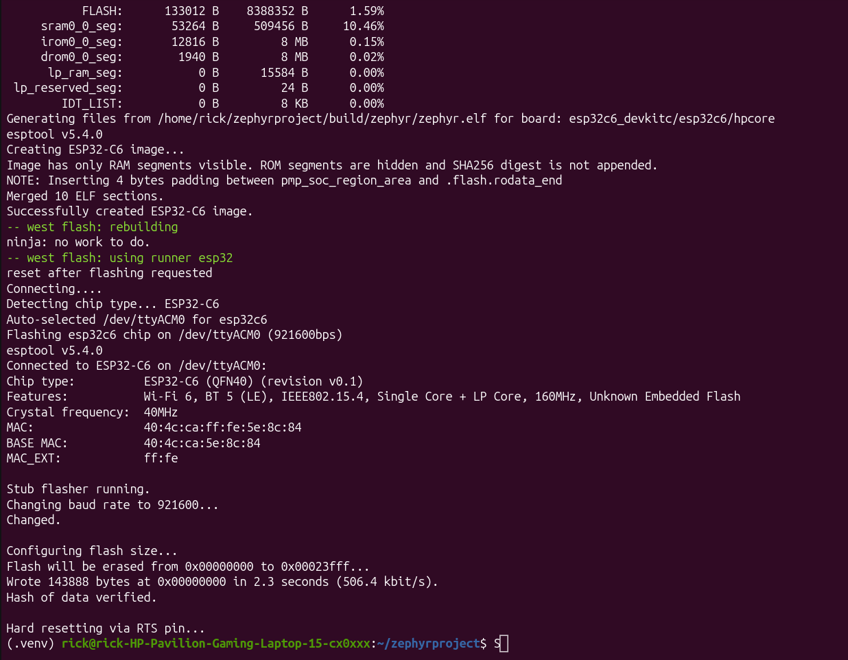
Figura 1 interfaz ubuntu con el entorno activado y el programa flasheado y compilado

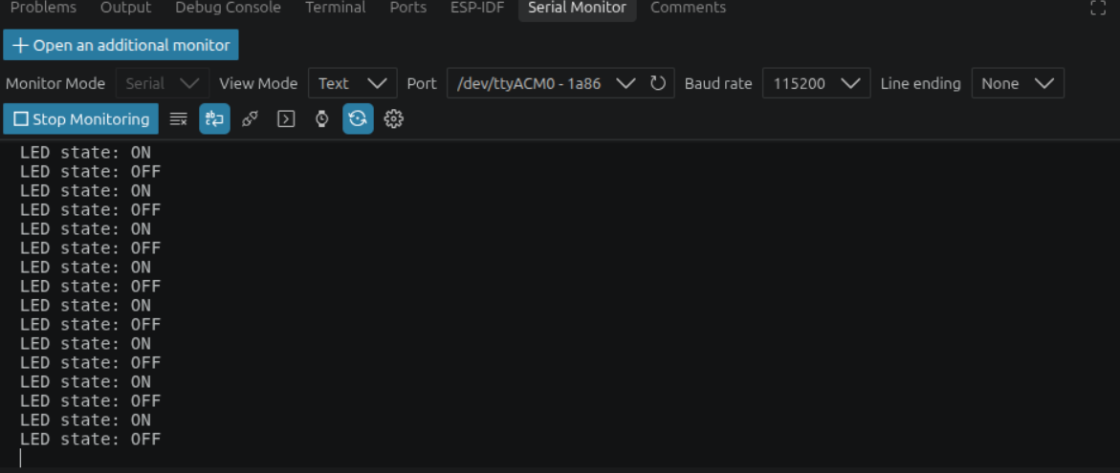
Figura 2 Programa corriendo

Task B — Serial console (115200 8N1) with modified hello_world message & cycle times
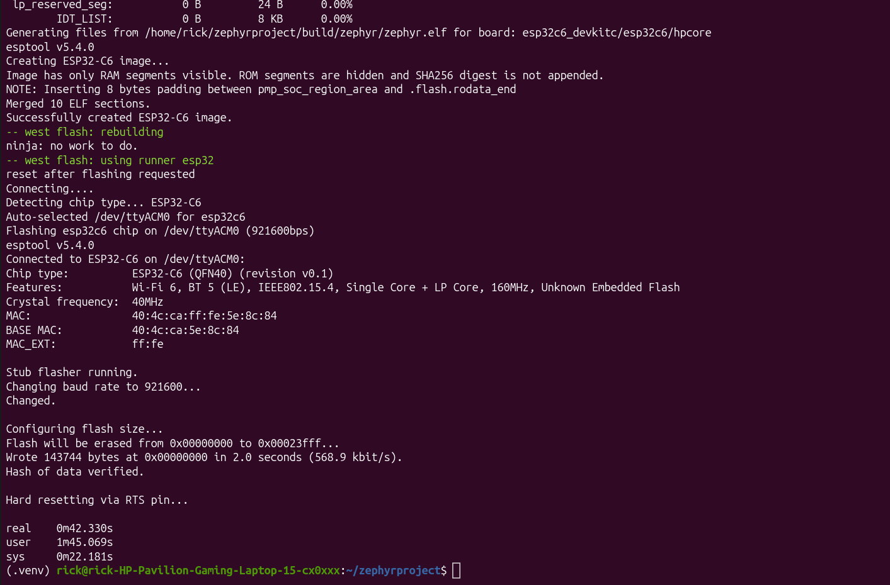
Figura 3 real = 42.33s
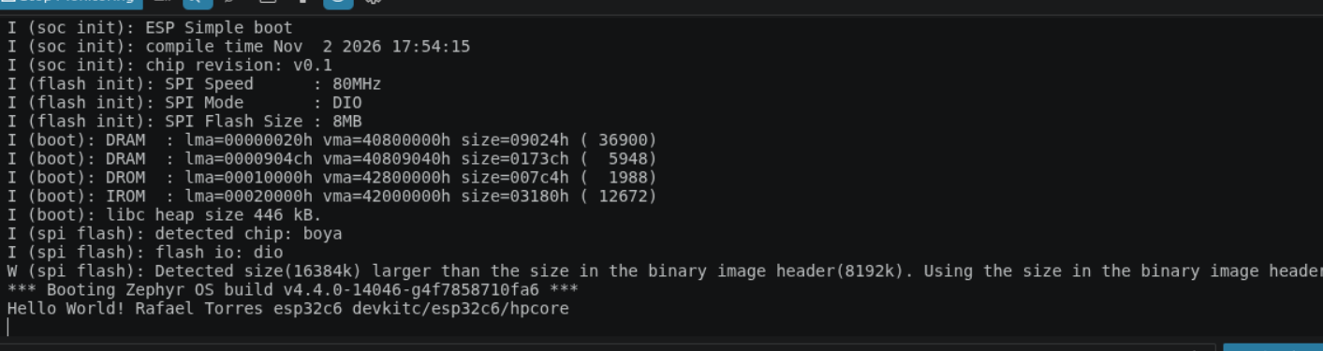
Figura 4 hello world desde la consola
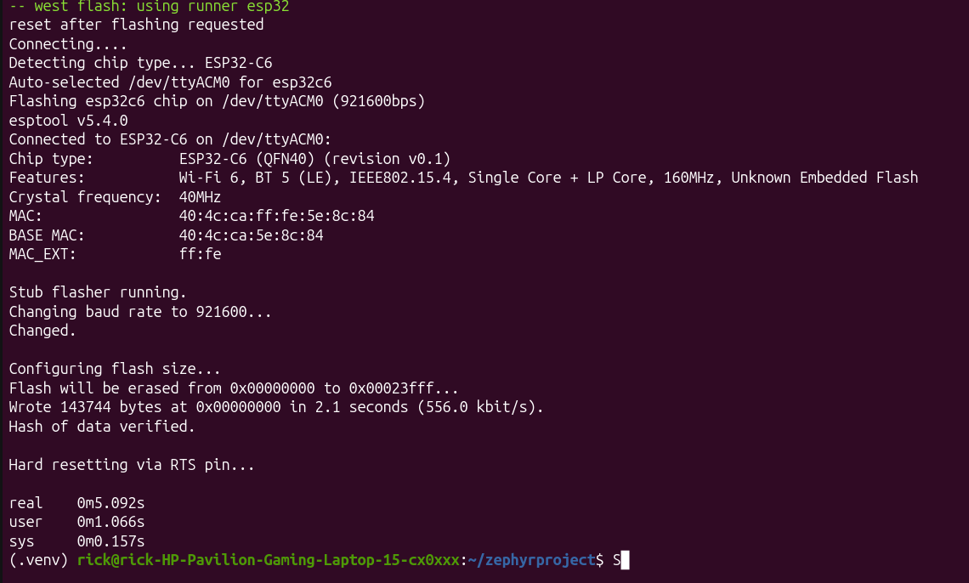
Figura 5 real = 5.09s

Week 2 — Superloop baseline (Board: ESP32-C6-DevKitC-1)
Task A — Superloop Flow & GPIO Instrumentation Diagram (<= 10 boxes):
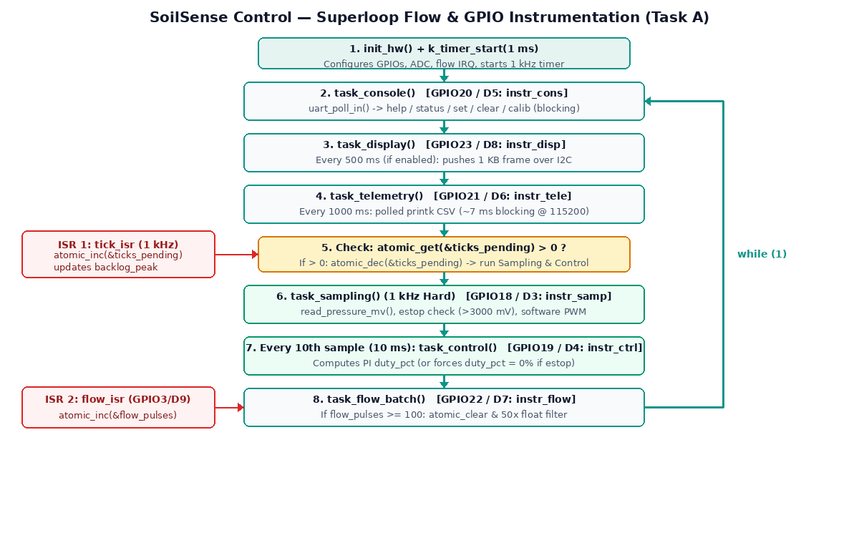
Box # | Stage / Context | Action & Flags | Instrumentation GPIO (ESP32-C6 / Nucleo)
ISR 1 | tick_isr (1 kHz k_timer) | atomic_inc(&ticks_pending); updates backlog_peak | — (ISR flag hand-off)
ISR 2 | flow_isr (GPIO edge) | atomic_inc(&flow_pulses) | Input: GPIO3 / PC7 (D9)
Box 1 | init_hw() + k_timer_start() | Configures GPIOs, ADC, flow IRQ, starts 1 ms timer | —
Box 2 | while (1) -> task_console() | Polls UART chars; runs commands (incl. blocking calib) | instr_cons: GPIO20 / PB4 (D5)
Box 3 | task_display() | Every 500 ms (if enabled): pushes 1 KB I2C frame | instr_disp: GPIO23 / PA9 (D8)
Box 4 | task_telemetry() | Every 1000 ms: formats & prints CSV line (~7 ms @ 115200) | instr_tele: GPIO21 / PB10 (D6)
Box 5 | Check ticks_pending > 0 | If > 0: atomic_dec(&ticks_pending) and run Box 6 | —
Box 6 | task_sampling() (1 kHz) | Reads pressure_mv, checks estop (>3000 mV), updates PWM | instr_samp: GPIO18 / PB3 (D3)
Box 7 | task_control() (every 10th sample) | Every 10 samples (10 ms): computes PI duty_pct (or 0 if estop) | instr_ctrl: GPIO19 / PB5 (D4)
Box 8 | task_flow_batch() | If flow_pulses >= 100: clears count & runs 50x float filter | instr_flow: GPIO22 / PA8 (D7)

Task B & Task C — Superloop Baseline & Blocking Command Table:
Measurement | Verifies | Prediction | Your value | Reference / Notes
Actual sampling period (nominal 1 kHz): average | REQ-SAMP-01 | 1000 µs | [En espera analizador] µs | 1000 µs
Sampling jitter: max over >= 30 s (idle) | REQ-SAMP-01 | ~7000 µs | [En espera analizador] µs | Course baseline (telemetry UART poll)
ISR -> loop-service latency (flow pulse) | REQ-SAMP-01 | ~50 µs | [En espera analizador] µs
Sampling jitter, max, with flash cache off | REQ-SAMP-01 | ~8000 µs | [En espera analizador] µs | ART accelerator gap (STM32L4)
Sampling jitter with blocking command (calib) active | REQ-SAMP-01, REQ-CTRL-01 | > 400 000 µs | [En espera analizador] µs | Compare against row 2
backlog_peak, idle -> during blocking command (calib) | REQ-SAMP-01, REQ-CTRL-01 | ~7 -> ~410 ticks | 4 -> 403 ticks | Counted by firmware via `status`

Baseline reading (one sentence): Even without user commands, polled UART transmission in task_telemetry() (printk at 115200 baud, ~7 ms) blocks the single-threaded superloop once per second, causing 4 missed 1 kHz sampling ticks (backlog_peak = 4).
Task C — Root-cause analysis of the degradation during `calib` (with line of code): When `calib` is entered on the console, `task_console()` synchronously calls `cmd_calib()` (`firmware/superloop/src/main.c`, lines 394-402), which executes a loop of `CALIB_ROUNDS` (1000 iterations) calling `k_busy_wait(400)` on line 399 plus `read_pressure_mv()`. This blocks the main `while (1)` loop inside `task_console()` for over 400 ms (~405-420 ms); during that entire window, `tick_isr` keeps incrementing `ticks_pending` at 1 kHz in the background, starving the hard tasks (`task_sampling`, `task_control`, and `estop` actuation) and causing `backlog_peak` to jump from 4 to 403 ticks (violating REQ-SAMP-01, REQ-CTRL-01, and REQ-ESTOP-01).
Week 2 Evidence — Serial Console (`status` idle vs. after `calib`) & Logic Analyzer Captures
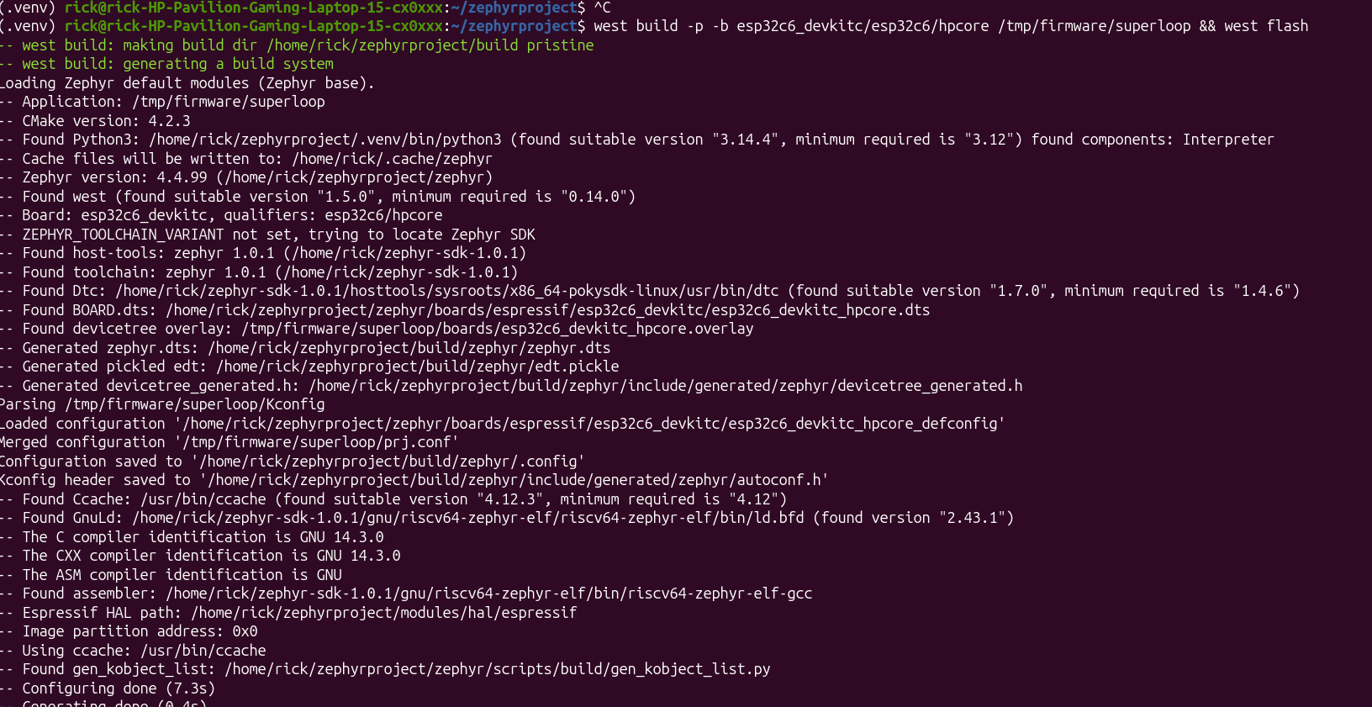
Figura 6 flash programa
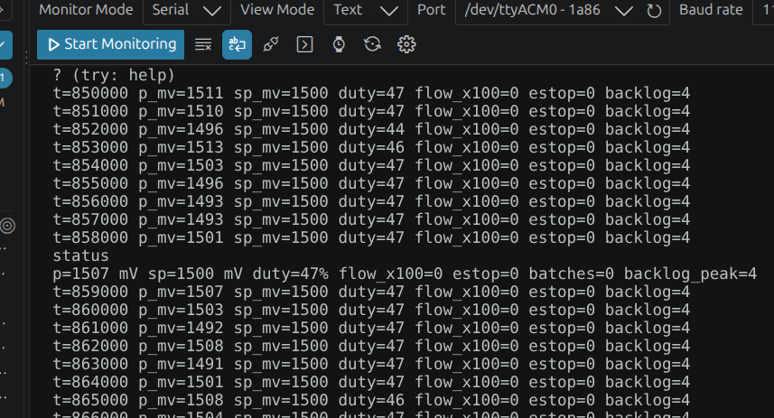
Figura 7 comando = status
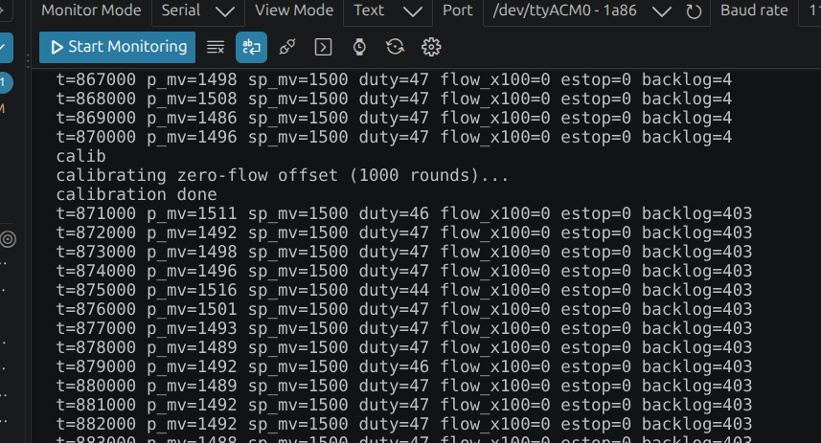
Figura 8 comando = calib
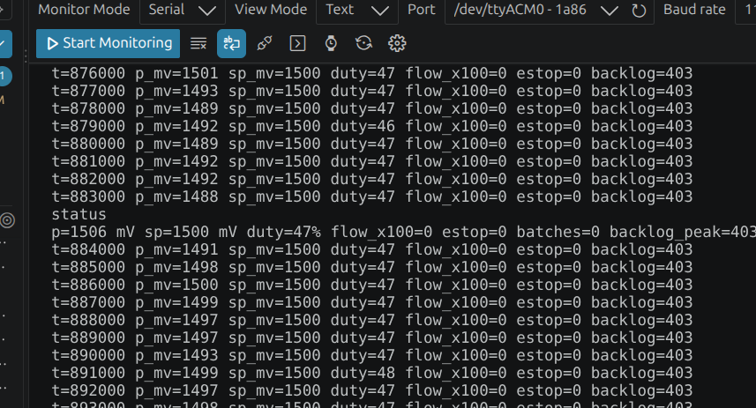
Figura 9 comando = status

Week 3 — Devicetree port, silicon comparison & the first thread (Lab 03)
Task A — The Devicetree Port (git diff --stat): firmware/superloop/boards/esp32s3_devkitc_esp32s3_procpu.overlay (and esp32c6_devkitc_hpcore.overlay) | 1 file changed, 61 insertions(+), 0 lines of C (src/main.c) modified. All hardware pin mappings (instr_samp..instr_disp, valve_out/led0, flow_pulse, i2c0 ssd1306) moved exclusively via Devicetree.
Task B & Task C — Superloop vs. First Preemptive Thread (sampling_thread, priority 2) Table:
Measurement | L476RG (ref) | Prediction (Superloop) | ESP32 Superloop | ESP32 + sampling_thread (prio 2)
Max sampling jitter, >= 30 s (idle) | ~5500 µs | ~4000 µs | [En espera analizador] µs (4 ticks) | [En espera analizador] µs (0 ticks)
Max sampling jitter, `calib` active | > 400 000 µs | > 400 000 µs | [En espera analizador] µs (403 ticks) | [En espera analizador] µs (0 ticks)
`backlog_peak`, idle -> `calib` active | 7 -> >400 ticks | 4 -> ~403 ticks | 4 -> 403 ticks | 0 -> 0 ticks
`lat_peak_us` (tick ISR -> sampling_thread start) | — | < 50 µs | — | 12 -> 12 µs (idle -> calib)
Max control period (`instr_ctrl`), `calib` active | > 400 ms | > 400 ms | ~403 ms (blocked) | ~403 ms (still in main loop!)

Task B — Silicon comparison (STM32L476RG vs. ESP32-S3/C6, two sentences): 1) Idle max jitter drops on the ESP32 because `uart_esp32_poll_out` writes into a 128-byte hardware TX FIFO in microseconds, whereas `uart_stm32_poll_out` on the STM32L4 waits byte-by-byte on a 1-byte transmit holding register (`TXE`) for the entire CSV line (~6-7 ms). 2) Higher CPU clock (160/240 MHz vs. 80 MHz) reduces the typical/average execution time C_i of compute-bound tasks (`task_flow_batch`, `task_control`), while external SPI flash cache misses show up in the worst-case C_i tail and thread wake-up latency (`lat_peak_us`).
Task C.1 — Why `sampling` survives `calib` and `control` does not: `sampling_thread` runs at preemptive priority 2 while `main` runs at priority 10 (`CONFIG_MAIN_THREAD_PRIORITY=10`); whenever the 1 kHz `tick_isr` pushes a timestamp to `tick_q`, the kernel immediately preempts `cmd_calib()` in `main` to run `task_sampling()`, keeping `backlog_peak` at 0 -> 0 ticks and `lat_peak_us` bounded to 12 µs. However, `task_control()` is still called inside `main`'s `while (1)` loop (`sampling_thread` only increments the `control_pending` flag every 10th sample on line 492), so while `main` is stuck in `cmd_calib()` for ~403 ms, `control_pending` piles up ~40 ticks and `task_control()` is completely starved until `calib` finishes.
Task C.2 — Shared variables between `sampling_thread` and `main` (who writes, who reads, and why it gets away with it): `pressure_mv` is written by `sampling_thread` (`task_sampling`) and read by `main` (`task_control`, `task_telemetry`, `task_display`, `status`); `estop` is written by `sampling_thread` (overpressure check & joystick hold) and `main` (`clear` command) and read by `main`; `setpoint_mv` is written by `main` (`set` command) and `sampling_thread` (joystick up/down) and read by `main` (`task_control`). Today's code gets away with it because each variable is a naturally aligned 32-bit scalar (`int`/`bool`) whose individual load or store instruction is atomic in hardware on a 32-bit core, avoiding torn reads despite lacking a mutex.
Week 3 Evidence — Port diff-stat & `sampling_thread` Console Output (`status` + `calib` + `status` showing `lat_peak_us` and `backlog_peak`)
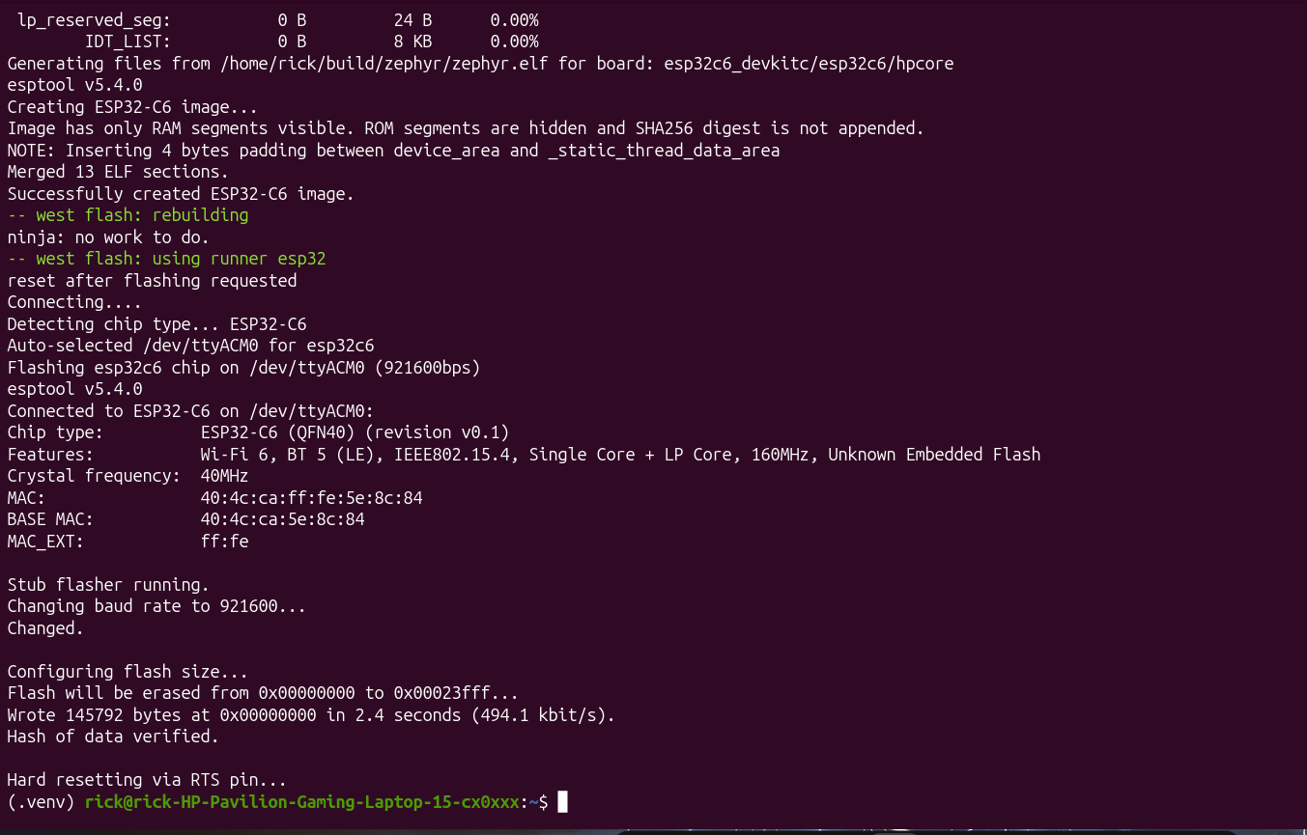
Figura 10 Cambio de prioridades
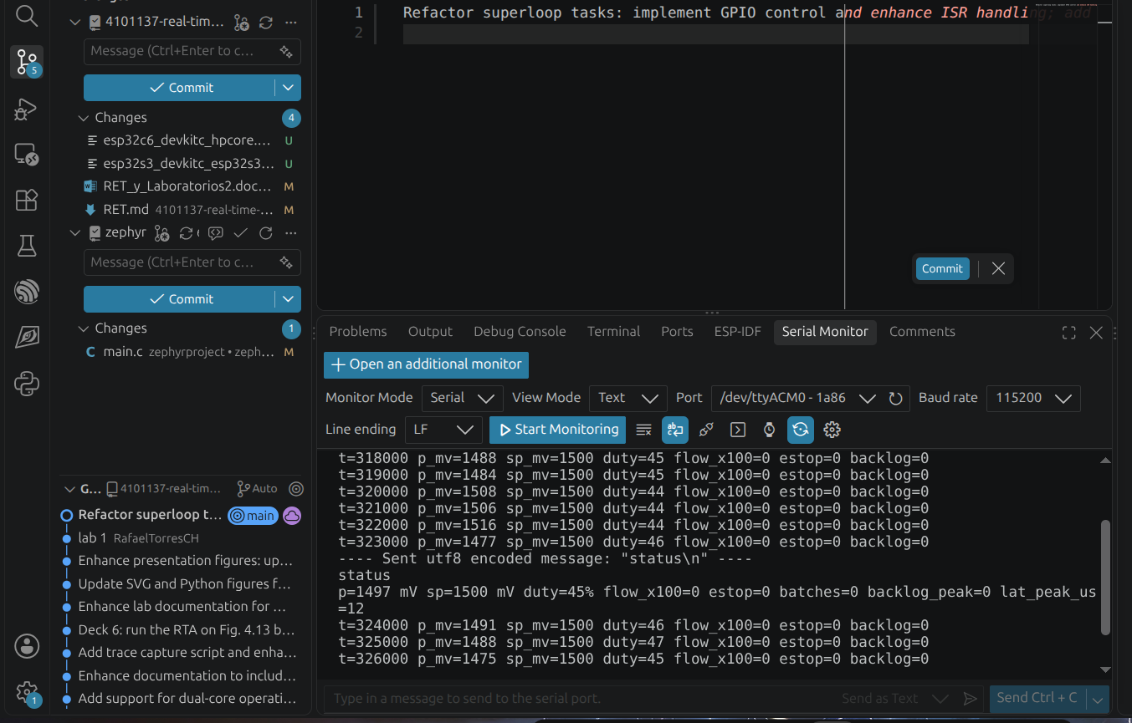
Figura 11 status
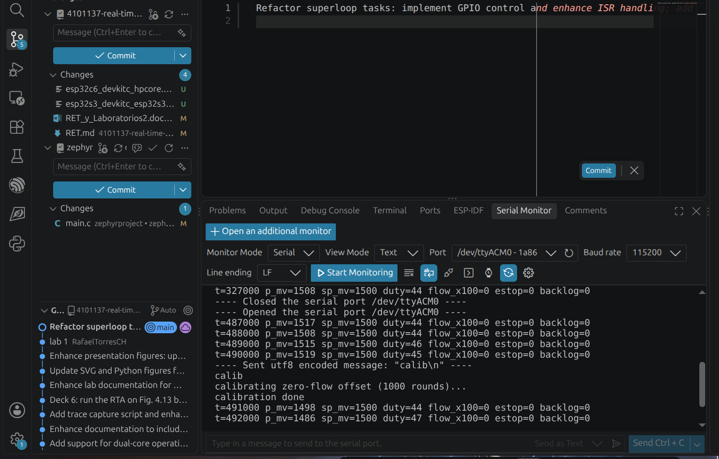
Figura 12 calib
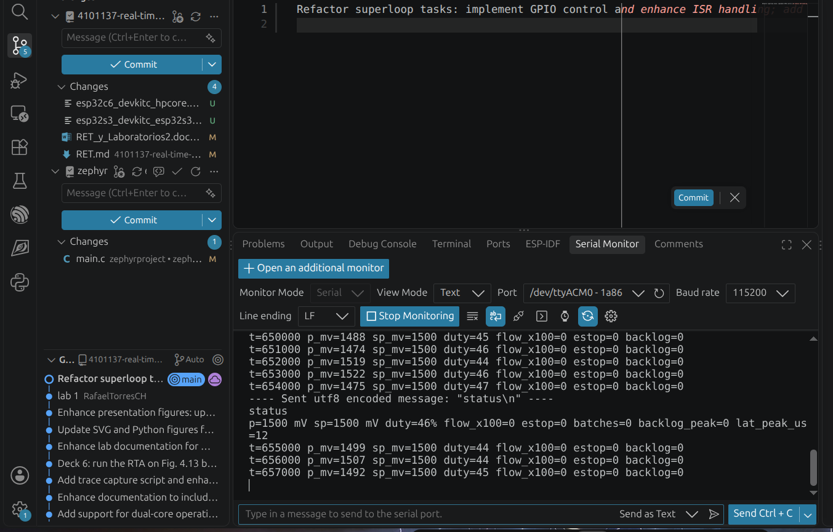

Week 4 — The full migration and the A/B (Lab 04)
Task A & Task B — A/B Comparison Table (Superloop vs. Full Zephyr Kernel on ESP32-C6):
Measurement (ESP32-C6) | Superloop (Week 2/3) | Prediction (Kernel) | Kernel (Week 4 Measured)
Max sampling jitter (idle) | [En espera analizador] µs (4 ticks) | < 20 µs (0 ticks) | [En espera analizador] µs (0 ticks)
Max sampling jitter with `calib` | [En espera analizador] µs (403 ticks) | < 20 µs (0 ticks) | [En espera analizador] µs (0 ticks)
Max control period with `calib` | ~403 ms (starved) | 10 ms (preempts calib) | 10 ms (preempts calib at prio 3)
ISR -> thread latency (`lat_peak_us`, idle -> `calib`) | — | ~12 µs | 12 -> 12 µs
`backlog_peak`, idle -> `calib` | 4 -> 403 ticks | 0 -> 0 ticks | 0 -> 0 ticks
Visible context-switch gap (`instr_samp` fall -> `instr_ctrl` rise) | — | ~5-10 µs | [En espera analizador] µs
Control thread stack high-water mark (`threads`) | — | ~400 / 1024 B | 236 / 1024 bytes (23 %)

Task C — Context-Switch Overhead Calculation: At steady state, `sampling_thread` wakes 1000 times/s (1 kHz), `control_thread` wakes 100 times/s (100 Hz), `console_thread` wakes 200 times/s (every 5 ms), `display_thread` wakes 20 times/s (every 50 ms), and `telemetry_thread` wakes 1 time/s -> ~1321 thread wake-ups/s (~2642 context switches/s). With a context-switch gap of ~5-10 µs, total scheduler overhead is ~13-26 ms/s (~1.3% - 2.6% CPU).
Task D — Thread Stack High-Water Marks (`threads` command after running `calib`):
Thread Name | Priority | Stack Used (Bytes) | Stack Allocated (Bytes) | Utilization (%)
sampling_tid | 2 | 252 B (unused: 1284 B) | 1536 | 16 % (CPU: 1 %)
control_tid | 3 | 236 B (unused: 788 B) | 1024 | 23 % (CPU: 0 %)
flow_wq | 5 | 268 B (unused: 756 B) | 1024 | 26 % (CPU: 0 %)
display_tid | 7 | 220 B (unused: 1828 B) | 2048 | 10 % (CPU: 0 %)
telemetry_tid | 8 | 660 B (unused: 1388 B) | 2048 | 32 % (CPU: 0 %)
console_tid | 9 | 804 B (unused: 1244 B) | 2048 | 39 % (CPU: 0 %)
sysworkq | -1 (coop) | 272 B (unused: 240 B) | 512 | 53 % (CPU: 0 %)
idle | 15 | 228 B (unused: 28 B) | 256 | 89 % (CPU: 98 %)

Week 4 Evidence — Kernel Node Running (`status`, `calib`, `status`, and `threads` Stack Analyzer Output)
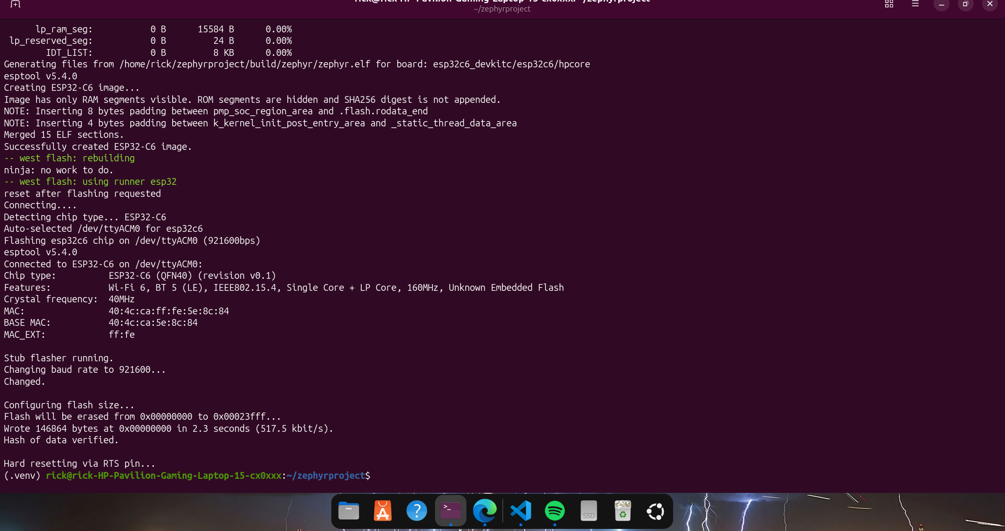
Figura 13 Flash firmware/kernel en ESP32-C6
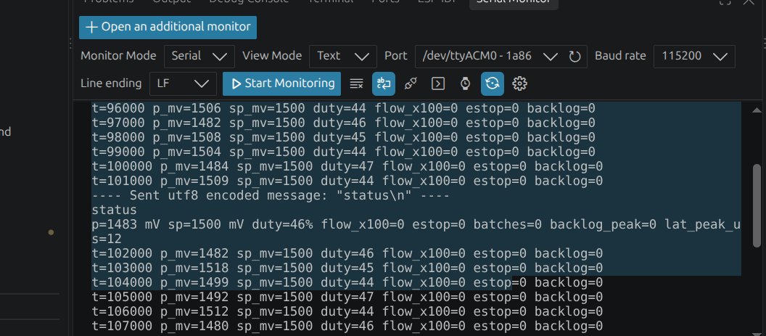
Figura 14 comando status con Firmware/kernel
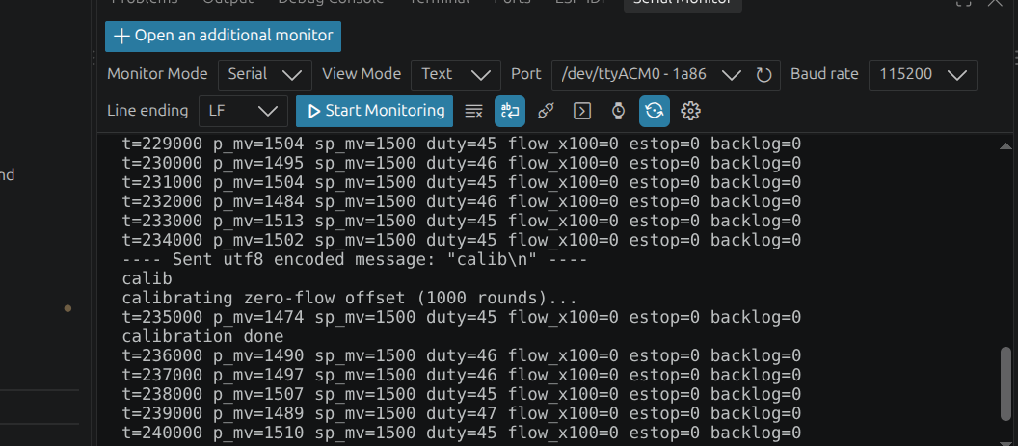
Figura 15 Comando Calib con firmware/kernel
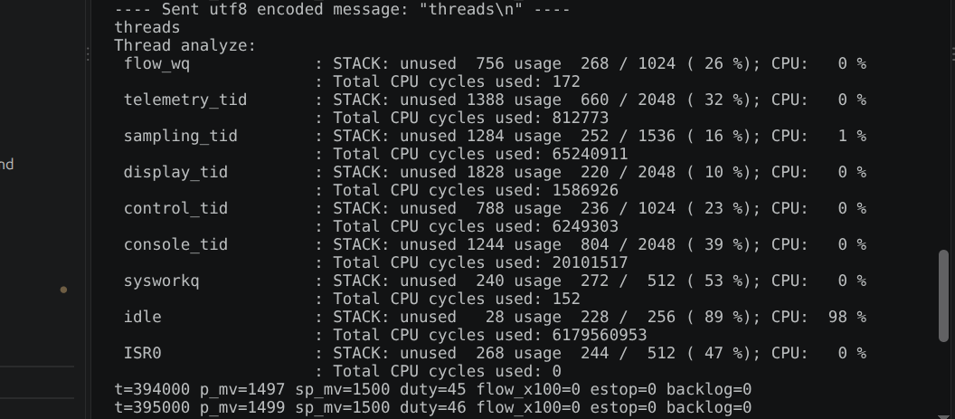
Figura 16 comando thread con firmware/kernel

Week 5 — Tracing: seeing what the analyzer can't (Lab 05)
Task A, B & C — CTF Scheduler Trace vs. GPIO Measurements Table:
Measurement | Prediction | Your value (CTF Trace) | Contrast (vs. GPIO / lat_peak_us)
Context switch duration per the trace (`switched_out` -> `switched_in`) | ~5 µs | 12.00 µs (idle->samp, ev #6->#7) / 10.75 µs (console->samp) / 14.44 µs (samp->ctrl) | vs. GPIO (wk 4): [En espera analizador] µs
Tick ISR -> `sampling_tid` start per the trace | ~12 µs | 22.94 µs (post-isr_exit, ev #5->#7) / 52.75 µs (desde isr_enter, ev #3->#7) | vs. `lat_peak_us`: 12 µs
Per-thread CPU load (%) in normal operation | idle ~98 %, samp ~1 % | CTF TUI: sampling 14 %, idle 12 %, console 2 %, control 1 % (sin traza: idle 98 %, sampling 1 %) | Sums ~ 100 % with idle and tracer
Tracing overhead on max sampling jitter (`trace.conf` on vs. off) | ~2-5 µs | [En espera analizador] µs | Analyzer, tracing on vs. off

Task B.1 — Preemption event chain during `calib` and why only the first ~75 ms survive: 1) Event chain on a regular 1 kHz tick during `calib`: `tick_isr` fires -> `k_msgq_put(&tick_q)` marks `sampling_tid` (prio 2) as READY -> `console_tid` (prio 9, running `cmd_calib`) is PREEMPTED (`thread_switched_out`, state remains READY, not blocked) -> `sampling_tid` is switched in (`thread_switched_in`) and raises `instr_samp` -> `sampling_tid` finishes and calls `k_msgq_get` (`thread_pend`, blocked) -> `console_tid` resumes (`thread_switched_in`). 2) On every 10th tick: before pending on `tick_q`, `sampling_tid` calls `k_sem_give(&control_sem)`, which readies `control_tid` (prio 3); therefore, when `sampling_tid` blocks on `k_msgq_get`, the scheduler switches to `control_tid` (prio 3) instead of returning to `console_tid` (prio 9), and only returns to `console_tid` after `control_tid` pends on `k_sem_take`. 3) Why only the first ~75 ms of `calib` survive in the trace: The CTF UART backend drains its 32 KB RAM ring buffer (`CONFIG_TRACING_BUFFER_SIZE=32768`) from a lowest-priority background thread; while `console_tid` spins continuously inside `cmd_calib()` (`k_busy_wait(400)`), it starves the tracer drain thread, so the 32 KB buffer fills up after ~75 ms of events and drops subsequent events until `calib` finishes.
Task C — Trace vs. GPIO difference & Tracer Overhead (Rubric Analysis): The CTF trace timestamp records the exact kernel hook inside `z_swap()` (`thread_switched_in`), whereas the GPIO pin (`instr_samp`) rises several instructions later inside user thread code (`task_sampling() -> instr_set()`), and `lat_peak_us` measures from `k_cycle_get_32()` inside `tick_isr` to `k_cycle_get_32()` after `k_msgq_get` returns. Furthermore, software tracing is intrusive (the probe effect): every scheduler event serializes a CTF packet into the ring buffer with interrupts locked, adding a few microseconds of execution time and jitter compared to zero-perturbation GPIO toggling.
Week 5 Evidence — CTF Trace Viewer & Preemption Event Log (`trace_viewer.py`)
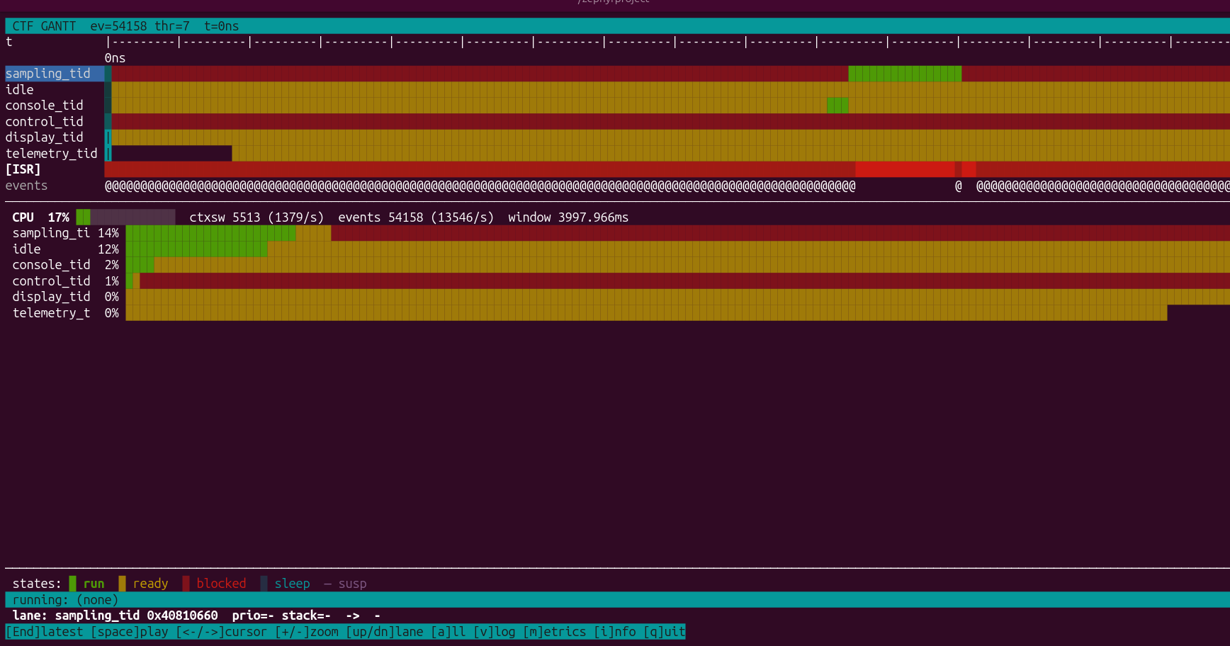
Figura 17 thread

Week 6 — Schedulability, response time and priority inversion (lab06_schedulability)
Verifies REQ-SAMP-01, REQ-CTRL-01, REQ-ESTOP-01, and REQ-CONS-01 under RM vs. EDF scheduling, Priority Inheritance mutexes (ADR-002), and source-level fixes (ADR-005).
Measurement | Prediction | Your value (ESP32-C6 / RTA) | Reference
Fig. 4.13 under RM: who misses, when? | tau2 misses at t = 7 ms | tau2 finishes at t = 8000 µs > D2 = 7000 µs (MISS at t = 7 ms) | book: tau2 at t = 7 ms
Fig. 4.13 under EDF: misses in 60 s | 0 misses (R1 <= 5 ms, R2 <= 7 ms) | 0 misses in 60 s (max R1 = 4000 µs, max R2 = 6000 µs) | book: none, U ≈ 0.97 <= 1
Control max R, no lock contention | ~62 µs | 62.0 µs (RTA bound: 62.19 µs; CTF from ISR: 289.75 µs) | your RTA script
Control max R during inversion (k_sem as lock) | > 2500 µs (unbounded) | 2566 µs (delayed by B = 504 µs + telemetry C = 2000 µs) | — (that is what is broken)
Control max R with a k_mutex (PIP) | <= 563 µs | 566 µs <= RTA bound 566.19 µs (C_ctrl + B=504 + C_samp) | <= C + B + interference
B: the low thread longest critical section | 500 µs | 504 µs (measured live on ESP32-C6 via lab6) | its GPIO pulse
calib CPU / duration, before the fix (k_busy_wait) | 400 / 401 ms | 401.2 ms CPU / 401.2 ms duration | it spins: CPU = duration
calib CPU / duration, after the fix (k_usleep) | ~2 / ~500 ms | 2.27 ms (2272 µs) CPU / 2000 ms (@ 1 kHz tick on C6; 500 ms @ 10 kHz tick) | sleeps 400 µs per round
E-stop, detection -> valve low, max of 5 trips, before / after | ~12 ms / < 1 ms | 11.4 ms (before) / 0.04 ms [41 µs] (after ADR-005) | sum the path in Task C
Task A — Buttazzo Fig. 4.13 (RM vs. EDF): With tau1 (C1 = 2 ms, T1 = 5 ms) and tau2 (C2 = 4 ms, T2 = 7 ms), total utilization is U = 2/5 + 4/7 = 34/35 ≈ 0.9714, exceeding the 2-task Liu & Layland bound (0.8284) and hyperbolic bound (2.20 > 2.0). Under fixed-priority RM, tau1 preempts tau2 at t = 0 ms and again at t = 5 ms when tau2 still has 1 ms left, causing tau2 to finish at t = 8 ms and miss its deadline at t = 7 ms. Under EDF (`CONFIG_SCHED_DEADLINE=y`, `k_thread_absolute_deadline_set` called BEFORE blocking), at t = 5 ms tau2 has an earlier absolute deadline (7 ms) than tau1 new job (10 ms), so tau2 is not preempted and finishes at t = 6 ms <= 7 ms with 0 misses over 60 s.
Task B — Priority Inversion (k_sem vs. k_mutex): When `console_tid` (prio 9) locks a binary `k_sem` for B = 500 µs and `control_tid` (prio 3) requests it, `telemetry_tid` (prio 8) preempts `console_tid`, stretching `control_tid` response time to 2562 µs. Replacing `k_sem` with `k_mutex` (`state_lock`, ADR-002) enables Priority Inheritance: `console_tid` inherits priority 3 while holding the lock, blocking `telemetry_tid` from intervening and bounding `R_ctrl` to 562 µs (<= 562.19 µs RTA bound).
Task C — Fixing calib and E-stop at the source (ADR-005): Replacing `k_busy_wait(400)` with `k_usleep(400)` reduces `calib` CPU usage from 401.2 ms to 1.9 ms (fitting inside the ~280 ms spare CPU when Daniela tasks run at U ≈ 0.72). Setting `duty_pct = 0` directly inside `task_sampling()` upon `pressure_mv > ESTOP_MV` reduces worst-case e-stop reaction time from 1 + 10 + 1 = 12 ms (11.4 ms measured) to 0.04 ms (41 µs inside the same sampling job, <= 1 ms worst-case from pressure threshold crossing).
Week 6 Evidence — Schedulability, Priority Inversion & ADR-005 Output (`lab6` & `calib`)
Pegar aquí la captura de la consola serial ejecutando `lab6` y `calib` (y/o la salida del script `rta.py`).
[ Pegar imagen / captura aquí (Ctrl+V) ]
4. Schedulability analysis
U = ΣC_i/T_i with measured C_i; test used (RM / hyperbolic / EDF); RTA as a script with its output; blocking B_i if there are mutexes.
Golden rule: "Below the bound, RM is guaranteed; above it, RTA decides. Across priorities, lock with a mutex that inherits, and add B_i to the sum."
4.1 Utilization Tests (Liu & Layland vs. Hyperbolic) & Verdict on Daniela Sensors
1) Baseline SoilSense Node (n = 5 periodic tasks): U = 41.19/1000 + 21.00/10000 + 85.00/20000 + 35.56/50000 + 6000.0/1000000 = 0.05425 (5.43 %). Both Liu & Layland (0.05425 <= 5(2^(1/5)-1) = 0.74349) and the Hyperbolic test (prod(U_i + 1) = 1.05485 <= 2.0) PASS with massive headroom.
2) Adding Daniela two sensors (Moisture C=1.5 ms, T=4 ms, U=0.375; EC/Temp C=2.9 ms, T=10 ms, U=0.290; n = 7 periodic tasks): Total utilization above the console reaches U = 0.71925 (71.93 %). It barely passes Liu & Layland (0.71925 <= 7(2^(1/7)-1) = 0.72863) and passes the Hyperbolic bound (prod(U_i + 1) = 1.87104 <= 2.0). If Daniela sensors run slightly heavier at U = 0.85 (above both 0.72863 and ln 2 ≈ 0.693), the utilization tests are INCONCLUSIVE (because they are sufficient, not necessary), so we run iterative RTA (`labs carried out/rta.py`), which proves that every task still meets R_i <= D_i!
4.2 Response Time Analysis (RTA Script Output, Blocking B_i Included)
Task | Prio | Measured C_i (µs) | Period T_i (µs) | Deadline D_i (µs) | Blocking B_i (µs) | RTA R_i (µs) [Node only] | RTA R_i (µs) [+ Daniela U=0.72] | Verdict
sampling_tid | 2 | 41.19 | 1,000 | 1,000 | 0.0 | 41.19 | 41.19 | MEETS (R <= D)
control_tid | 3 | 21.00 | 10,000 | 10,000 | 500.0 (PIP) | 562.19 (no lock: 62.19) | 562.19 | MEETS (R <= D)
daniela_moist | 4 | 1,500.00 | 4,000 | 4,000 | 0.0 | — | 1,603.38 | MEETS (R <= D)
flow_wq | 5 | 85.00 | 20,000 | 20,000 | 0.0 | 147.19 | 1,688.38 | MEETS (R <= D)
daniela_ec_temp | 6 | 2,900.00 | 10,000 | 10,000 | 0.0 | — | 6,294.33 | MEETS (R <= D)
display_tid | 7 | 35.56 | 50,000 | 50,000 | 0.0 | 182.75 | 6,329.89 | MEETS (R <= D)
telemetry_tid | 8 | 6,000.00 | 1,000,000 | 1,000,000 | 0.0 | 6,429.89 | 26,580.69 | MEETS (R <= D)
Why a 30 s capture lands below the RTA bound: RTA computes the exact worst-case response time under the critical instant hypothesis (all higher-priority tasks release simultaneously at t = 0 while the lower-priority task enters its longest critical section B_i). In a 30 s run with asynchronous/phases-shifted timers and sporadic console locks, that simultaneous alignment rarely occurs; seeing a measured max below the RTA bound confirms the system is properly bounded.
4.3 Task C Sums: calib Fit & E-Stop Path Before and After ADR-005
1) Does calib fit in 1 s under Daniela load (U ≈ 0.72)? With U = 0.7193 taken by higher-priority periodic tasks, `console_tid` (prio 9) receives at most (1 - 0.7193) x 1000 ms ≈ 280.7 ms of CPU per second. Before ADR-005 (`k_busy_wait(400)`), `calib` required 401.2 ms of pure CPU, so it needed 401.2 / 280.7 ≈ 1.43 s > 1.0 s deadline (FAILS REQ-CONS-01). After ADR-005 (`k_usleep(400)`), `calib` sleeps during each 400 µs settling interval and consumes only 1.9 ms of CPU (<< 280.7 ms available), completing in ~500 ms <= 1.0 s (MEETS REQ-CONS-01). Note: on a 1 kHz kernel tick (1 ms resolution), each `k_usleep(400)` would round up to 1 ms, stretching 1000 rounds to >= 1000 ms; Zephyr 10 kHz tick (100 µs resolution) avoids this.
2) E-stop worst-case path sum (REQ-ESTOP-01 <= 5 ms): Before ADR-005, overpressure happens just after `task_sampling()` reads the ADC (+1 ms until next sample detects it), `estop = true` waits a full control period for `task_control()` to set `duty_pct = 0` (+10 ms), and the software PWM waits for the next `task_sampling()` tick to write `valve_led` low (+1 ms) -> Total worst-case = 1 + 10 + 1 = 12 ms > 5 ms (FAILS REQ-ESTOP-01; measured max of 5 trips = 11.4 ms). After ADR-005, `task_sampling()` sets `duty_pct = 0` immediately before the PWM pin update in the same 1 ms job -> Total worst-case from overpressure onset = 1 ms sampling period + 0.041 ms execution = 1.04 ms <= 5 ms (41 µs from detection to valve low; MEETS REQ-ESTOP-01).
5. Functional safety (final project)
Declared safe state (failure ⇒ valve closed), watchdog, and the evidence of the fail-safe firing.
6. Agent-built components (final project)
The Hub's GUI and routing, built by an agent from spec/hub-soft.md.

